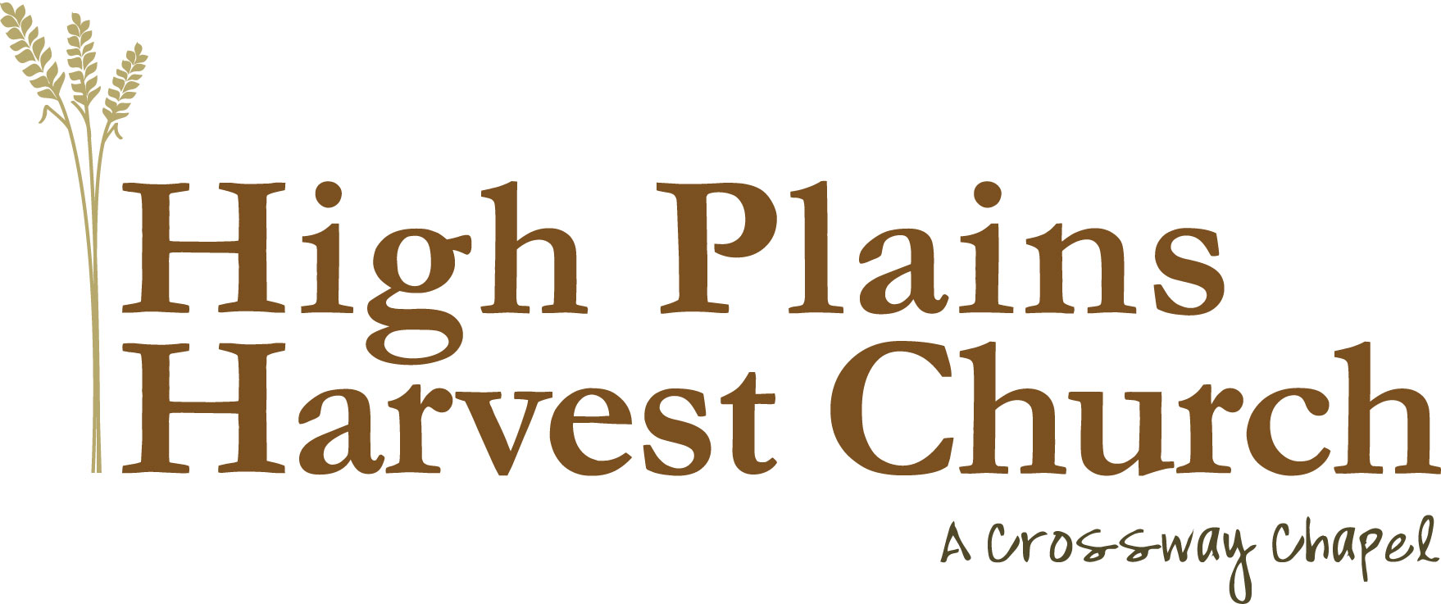
CHECK REQUEST FORM

Note: Please make sure this form is submitted before the expense is made. All checks will be
written in the middle and end of each month. Checks will be mailed to the address provided
unless otherwise indicated. All forms need to be approved and signed off by a Pastor/Elder Board
member or it will be returned. Please account for the request in your ministry budgets. Thank You.

Date: _____________________

Name of Person Requesting Check: ___________________________________________________________

Check Payable To: ________________________________________ Amount $ _________________

Purpose: ____________________________________________________________________________
____________________________________________________________________________

Address Check Will Be Mailed To:________________________________________________________________
________________________________________________________________
________________________________________________________________

Budget Category: ______________________________________

Approved by: ____________________________________

-- FOR OFFICE USE ONLY—

Date PAID __________ Check # __________ Amount PAID $ __________

High Plains Harvest Church .. P.O. Box 62 Ault, CO 80610 .. 970-897-2915

