CHILDREN’S MINISTRY  Servant Application | 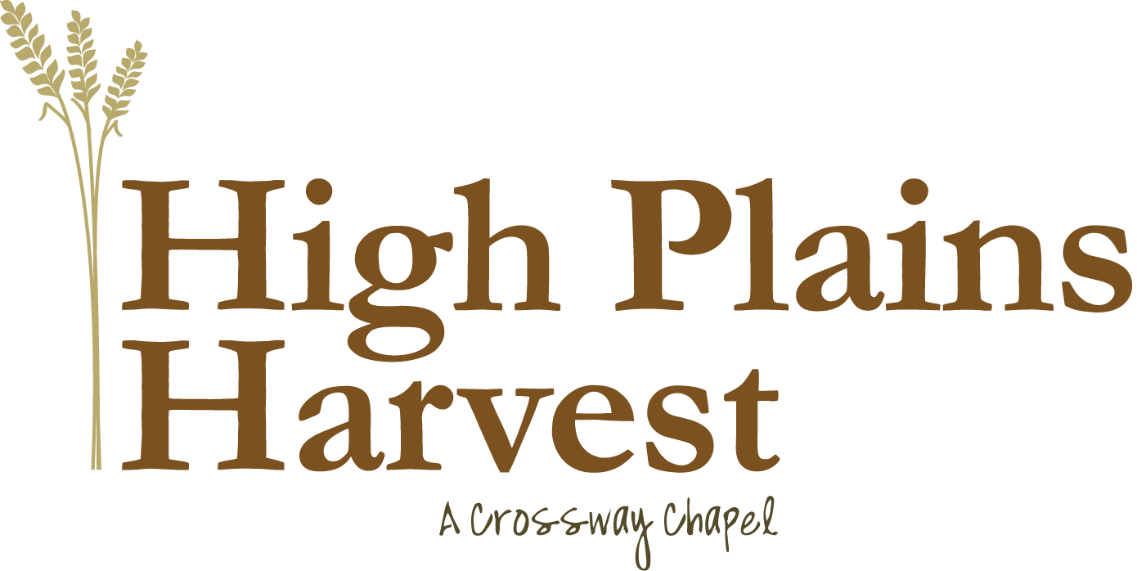
Name:
Address:
Daytime Phone: |  |  |  |  |  |  |  |  |  |  |  |  |  |  |  | Work Phone:
Cell Phone: |  |  |  |  |  |  |  |  |  |  |  |  |  |  |  | E-mail Address:
Birth Date: |  |  |  |  |  |  |  |  |  |  |  |  |  | Social Security Number:
Driver’s License Number: |  |  |  |  |  |  |  |  |  |  |  |  |  |  |  |  |  |  | State: |  |  |  |  |  |  |  | Expires:
Marital Status: |  |  |  |  |  |  |  |  |  |  |  |  | Spouses Name:
Names and Ages of Children:
Why do you want to be involved in this ministry?

Employment Information
Current Employer: |  |  |  |  |  |  |  |  |  |  |  |  |  |  |  |  |  |  |  |  | Number of Years:
Contact Person at Employer: |  |  |  |  |  |  |  |  |  |  |  |  |  |  |  |  |  |  |  | Phone Number:
Personal References (Must be at least 18 years old and not related to you)
(1) Name: |  |  |  |  |  |  |  |  |  |  |  |  |  |  |  |  |  |  |  |  |  |  | Relationship:
Address: |  |  |  |  |  |  |  |  |  |  |  |  |  |  |  |  |  |  |  |  |  |  |  |  |  | Phone:
(2) Name: |  |  |  |  |  |  |  |  |  |  |  |  |  |  |  |  |  |  |  |  |  |  | Relationship:
Address: |  |  |  |  |  |  |  |  |  |  |  |  |  |  |  |  |  |  |  |  |  |  |  |  |  | Phone:

Ministry Involvement
How long have you attended HPH? |  |  |  |  |  |  |  |  |  |  |  |  |  |  |  |  |  | Have you taken Biblical Priorities?
Are you currently a part of a Small Group? |  |  |  |  |  |  |  |  |  |  |  |  |  |  |  |  |  | Name of Small Group Leader:
List ministries currently involved in at HPH:
Last church you were a part of: |  |  |  |  |  |  |  |  |  |  |  |  |  |  |  |  |  |  |  |  |  |  |  | Location:
Contact person and phone number at church:

Your Spiritual Journey
Do you have a personal relationship with Jesus Christ?
Briefly describe how God intervened in your life and drew you to Himself:

The following questions are intended to help provide a safe and secure environment for our children. The answers to these questions are held confidential by the Children’s Celebration staff.

- Have you had any experiences that might make it difficult for you to minister to the children at High Plains Harvest Church? ________ If so, please explain.

- Do you have any health issues that could place the children at High Plains Harvest Church at risk? ________ If so, please explain.

- Have you ever been involved in any of the following inappropriate sexual activities: child pornography, child molestation, or homosexuality? ________ If so, please explain.

- I authorize High Plains Harvest Church to conduct a criminal background check.
(This is a requirement for anyone to serve in the children’s ministries)

- I affirm that the information contained in this application is true. I authorize High Plains Harvest Church to verify the information in the application with any references listed. I release all such persons or entities from liability that may result or arise from High Plains Harvest Church’s collections of all such evaluations or information or its consideration of my application.

- I have read the policy and procedure booklet for the children’s ministry and am in agreement with its contents.

or

- I have read the policy and procedure booklet for the children’s ministries and have the following questions/concerns…

Signature: _____________________________________ Date: ___________________

